Jason Kozel

Lesson Plan Title-
Picture description game

Objectives-
After completing this lesson students will be able to…
- …demonstrate a basic ability to communicate using the English language.
- …analyze how best to communicate their thoughts using the English language.
- …explain a picture and word to a classmate using the English language.
- …invent creative ways to exercise their classmates’ understanding of the English language.

Discipline and Topic-
English as a Foreign Language: Communication through gameplay.

Target Population-
This lesson will be presented to a class of 10 beginner-intermediate level English speaking students. The students will be between the ages of 10-13years. The class has been grouped based upon their ability for speaking English.

Curriculum Links-
This lesson satisfies the NYS Standard numbers 1.3, 1.12, 1.15, 4.3, 4.4, and 4.7—4.12 for middle school ESL students. The focus of this lesson is to get students speaking with one another. Particular attention should be given to the peer to peer regulatory aspects of this lesson and the minimal presence and/or influence of the teacher.
http://www.emsc.nysed.gov/biling/resource/ESL/05Com.pdf

Materials Description and Timing-
- This lesson will take place over the course of one (50 minute) class period.
- 2 small white/chalkboards (one for each team).
  - White board markers or chalk
  - Erasers

Scope and Sequence-
- Teacher will state the objectives of the lesson in very simple terms.
- The students will work in randomly selected groups of 4-5 people.
- Teacher will write the rules of the game on the board at the front of the room.
- Teacher will carefully go through the rules with the students.
  - 1) First, Team 1 will draw a picture and write the English word for the picture. Please do not show Team 2.
  - 2) One person from team two comes to the front.
  - 3) One person from Team 1 stands behind the Team 2 person at the front.
  - 4) Team 2 tries to get their teammate to say the word written by Team 1. Team 2 has 1 minute to succeed.
  - 5) If Team 2 is successful they get a point.
6) Team 1 now draws a picture and one person from Team 2 comes to the front of the room.
- Teacher will ask each group to pick a name for their team.
  - Teacher will write each team name on the board at the front of the room.
- Teacher will demonstrate an example round of game play with two student volunteers.
- Teacher will ask students to begin playing the game.
  - Teacher may have to select first round participants in the interest of time.
- Students will play the game until 5 minutes remain.
- Teacher will ask students opinions of the game.
  - Was it fun?
  - Was it boring?
  - Did you like it?
  - Etc…

Supplemental Materials-
- Directions handout.

Evaluation of Students-
The teacher’s assessment will be based upon the rubric below. There will be no formal assessment given. The rubric below is merely to judge the performance

Objective | Needs Work | Developing | Accomplished
Student demonstrated a basic ability to communicate using the English language. | Student did not try to demonstrate a basic ability to communicate using the English language. | Student adequately demonstrated a basic ability to communicate using the English language. | Student thoroughly demonstrated a basic ability to communicate using the English language.
Student analyzed how best to communicate their thoughts using the English language. | Student did not try to analyze how best to communicate their thoughts using the English language. | Student adequately analyzed how best to communicate their thoughts using the English language..” | Student thoroughly analyzed how best to communicate their thoughts using the English language.
Student explained a picture and word to a classmate using the English language. | Student did not try to explain a picture and word to a classmate using the English language. | Student adequately explained a picture and word to a classmate using the English language. | Student thoroughly explained a picture and word to a classmate using the English language.
Student invented creative ways to exercise their classmates’ understanding of the English language. | Student did not try to invent creative ways to exercise their classmates’ understanding of the English language. | Student satisfied the minimum requirements for participation and created a coherent narrative in English that compliments the short film “Twit Twit.” | Student actively participated in the creation of a coherent narrative in English that compliments the short film “Twit Twit.”

Evaluation of Lesson-
This lesson will be considered a success if students…
- …actively participate in the game by speaking.
- …speak clearly and are understood by their classmates when speaking English.
- …self-correct their pronunciation as well as seek advice from the teacher.
- …exercise their knowledge and understanding of the English language.
- …use the strategies found in the game during future lessons.

Rationale -
This lesson purposes to create an open-ended learning environment for the purpose of individual and group English language exercise and exploration. The peer-to-peer regulatory language scenarios that will no doubt form during the course of the lesson activity should be fostered and monitored by the teacher. Feedback from student to student and from the teacher to the students should be constructive and helpful to the learner. Alice Omaggio Hadley states, “More recent scholarship investigating the role of feedback in the development of oral skills continues to look at the questions of which errors should receive feedback, when feedback should be given, and what types of feedback are most useful” (p. 268). It is of my opinion that feedback should resemble real life language situations. I find the clarification technique to be a useful way to achieve this aim.

According to past research Hadley explains, “Clarification requests… were responses where teachers indicated they didn’t understand what the student said by saying something like ‘Pardon’” (p.268). This exchange is natural and similar to what a language learner would encounter when trying to communicate with an unfamiliar native speaker of English. I find this technique to be most useful in my own language learning experiences. When speaking with Koreans in Korean I often ask for clarification, simplification or repetition. Clarification request technique is non-invasive and positive for the learner. The lack of negativity allows for the learner to immerse themselves in the target language while comfortably making and assessing their own mistakes as well as the mistakes of others.

This lesson also touches upon the idea of learning within a community. Language learning should involve communication as much as possible. This seems obvious due to the subject matter being learned, but all too often it seems teachers revert to “sage on the stage” teaching techniques. By creating an environment where language can freely “bounce around the room” we allow for expression and creativity that can only be learned through practice. John D. Bransford et al state, “Although a great deal of children’s learning is self-motivated and self-directed, other people play major roles as guides in fostering the development of learning in children. Such guides include other children as well as adults (caretakers, parents, teachers, coaches, etc.)” (p. 82). Free expression should be encouraged and mistakes should be made so that language learners can build upon their existing knowledge in productive and practically viable ways.

Learning within a community using non-invasive techniques, like clarification request, helps the language learner become comfortable and receptive. A reproduction of real world scenarios within the classroom prepares the student for communicating in a way that is practically sound. This lesson purposes to successfully achieve these aims to promote a positive and fulfilling language learning environment.

References
Hadley, A. O. (2001). Teaching language in context. Singapore: Heinle and Heinle.

National Research Council. (2000). How People Learn. (J. D. Bransford, A. L. Brown, & R. R. Cocking, Eds.) Washington, D.C.: National Academy Press.

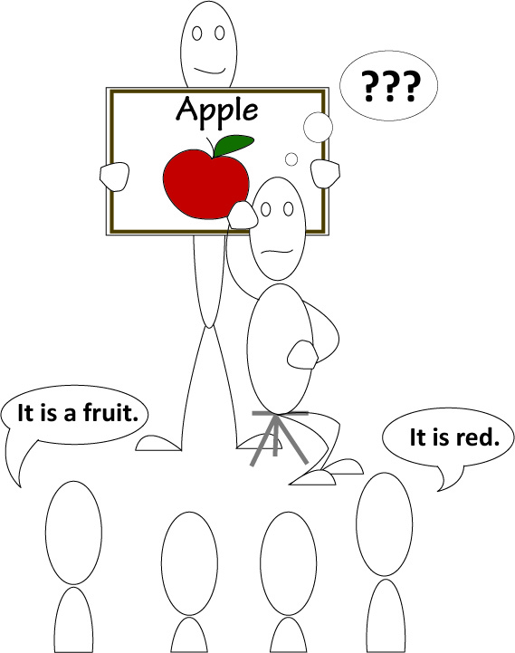
Team 1
Team 2
Team 2 (all)

