The House, the Apartment and the Home
PowerPoint (2007) Tutorial
OK! Let’s get started.
- Using vocabulary from the home (house/apartment) please find your clip art: http://office.microsoft.com/en-us/

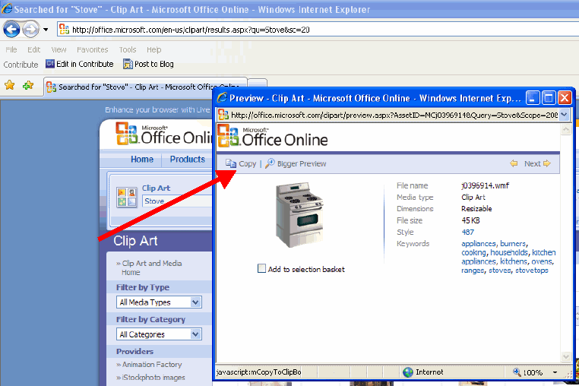
- Copy your clip art.

You have copied the image. Good job!

- Right click your blank PowerPoint presentation and select paste (see next page).
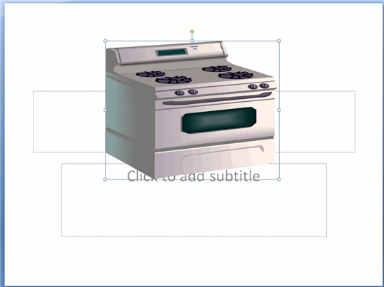

- Please find a “correct answer” button: http://office.microsoft.com/en-us/. Type “yes” and search for an image. Please repeat steps 2 and 3.

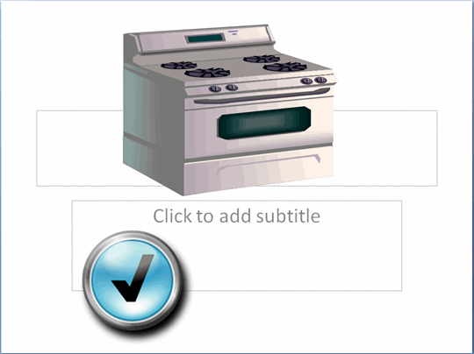
Woah! That looks great! Nice Work!
- Now let’s find a “wrong answer” button http://office.microsoft.com/en-us/. Type “no” and search for an image. Please repeat steps 2 and 3.

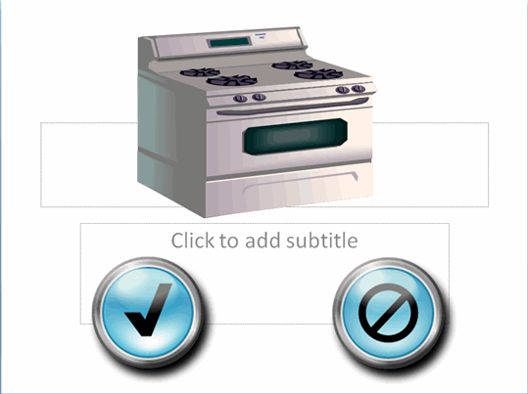
VERY COOL! Good work!

- Let’s add some animation! Click the Animations tab at the top of your screen. Then click the Custom Animation button.
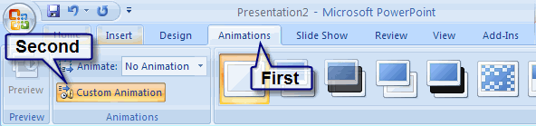

- Click the “correct answer” button. There is now a box around the “correct answer” button.

- Please click the Add Effect button on the right side > Click Emphasis > Click More Effects. Please choose an effect. Make sure you test your animation!

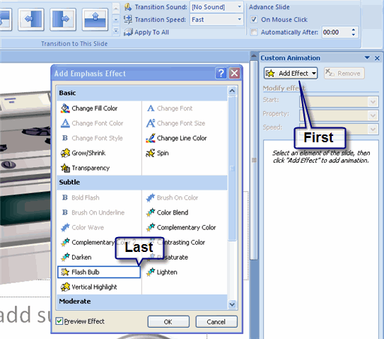

- Now let’s add sound. Click the arrow next to your effect > Click Effect Options.
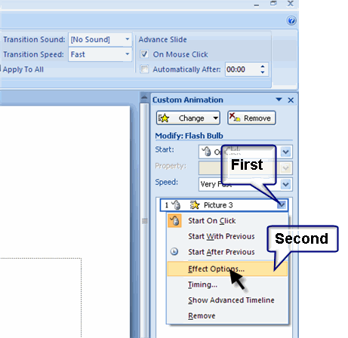

- Click the area next to the area for Sound > Select a noise for your effect.
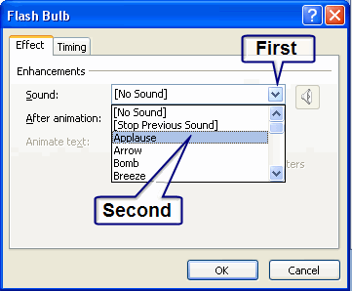
WOAH! You are getting good!
- It is time to add the trigger. Click the Timing tab > Click the Triggers button > Click the circle for Start effect on click of: > Match the trigger with the effect.

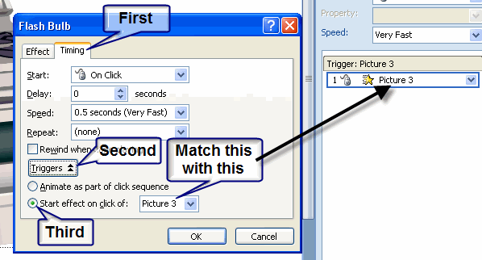
Are you a professional? You are AMAZING!

- Now test your animation! You should repeat steps 6-11 for the “wrong answer” button.

--End of Tutorial--

